PORTFOLIO 2
STUDENT SUBMISSION

Student Name: Add your name here Student ID: Add number here

Stream: Add Year and Semester

Submit this document by the due date to Moodle when you have completed it.

BUILDING ENVELOPE
Introduction
This course covers the general practical and theoretical knowledge of the principles related to weather tightness in plumbing and gas fitting and further develops work-readiness capabilities.
Learning Outcomes:
By the end of this course the student will be able to:
- Work safely at heights (Assessed by an external provider)
- Describe the main principles of weather tightness in plumbing and gas fitting
- Describe methods of preserving the structural integrity and prevention of damage to property
- Install water tight roof and wall cladding pipe penetration systems
- Install basic roof cladding and flashings (e.g. corrugated steel system) There is an additional couple of pages here so you can add the photos of your sketches of the roof styles. Also the photos of the different roofs in your neighbourhood with details of their Roof Style, Roof materials and their gutter and downpipe type.
- Apply work-readiness capabilities

I ____________________________________ certify that this is my own work.

Learning Outcome 2:
- Describe the main principles of weather tightness in plumbing and gas fitting

This outcome is assessed in two ways:
- Online lesson in Moodle. You will be asked questions about the 4D’s of Weather tightness.
- Photograph of a roofing or pipe penetration job you have completed showing the features and strategies used to keep building structures water tight. Please label your photograph so your Tutor can see what you are referring to.
Add Labelled photograph of your work here

List 3 or more ways you have kept this installation weather-tight.
- Add explanation here
- Add explanation here
- Add explanation here
- Add explanation here
Learning Outcome 3:
Describe methods of preserving the structural integrity and prevention of damage to property
Using the provided headings describe what the plumber needed to plan for and adhere to in this job to preserve structural integrity and prevent damage to property.
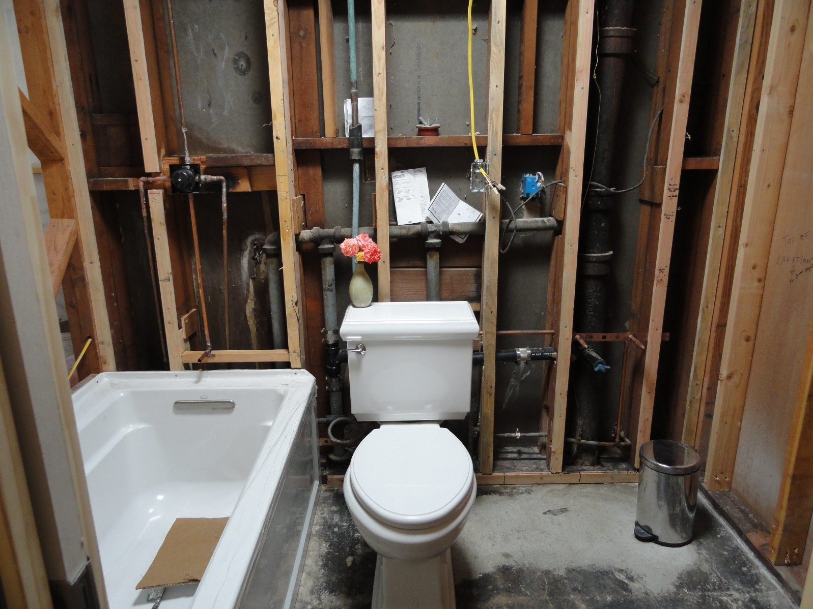
Code requirements:
Notching and drilling into structural material:
Add text here
Penetrations through walls and floors:
Add text here
Care of the customers property:
List at least 4 precautions to take care of the customers property?
Learning Outcome 4:
Install water tight roof and wall cladding pipe penetration systems
Create an instructional job card

An instructional Job card will include the following:
- The installation steps in order from beginning to end
  - These might include acceptable solutions for the job
- Tool list
- An equipment (fittings / fixtures list)
- A completed Health and Safety Risk Assessment form.
- Any legislative requirements that need to be followed
May include:
- a sketch or diagram describing the job
- Any relevant calculations

Roof and Wall pipe penetration
Tools Required:  - Add to this list | Fittings and Fixtures Required:  - Add to this list
PROCEDURE
Step:
- What needs to be prepared for this job
- Add to your procedural list here

LEGISLATION
- Reference any legislation that relates to this job or the environment the appliance / fitting is located in.
- Add to list here
- Add to list here
CALCULATIONS

Add an image of any calculations you did here

HEALTH AND SAFETY RISK ASSESSMENT
Complete the following form for this job as a hard copy and get your Tutor to sign it. Add a quality photo or photocopy of your completed form in the space below.

HEALTH AND SAFETY RISK ASSESSMENT FORM
ACTIVITY: Roof and Wall pipe penetrations

IDENTIFY RISKS: Highlight / tick those that apply
Tick the potential risks(s) for this activity:
- Slips, trips and falls | - Heavy items that could fall | - Sharp objects or tools | - Electrical equipment (incl. power tools)
- Gas equipment | - Machinery (moving parts) | - Machinery (sparks) | - Hand tools
- Toxic fumes and dust | - Poisonous chemicals | - Flammable substances | - Excessive noise
- Ladders (heights) | - Temperature | - Fatigue | - Flames
List any other risks:
Add text here

RISK CONTROL METHOD:
Write what you will do to eliminate or minimise each risk:
RISK: | WHAT MIGHT HAPPEN: | HOW YOU WILL ELIMINATE: | HOW YOU WILL MINIMISE:
PERSONAL PROTECTIVE EQUIPMENT (PPE):
Tick the personal protective equipment (PPE) needed to complete this activity:
- Footwear | - Overalls | - Safety glasses | - Safety gloves
- Welding mask | - Earmuffs / earplugs | - Hard hat | - Hi-vis vest
List any other personal protective equipment (PPE) required:
Add text here

Add text here
Write or draw about what you plan to do to complete this activity.
PLANNING:

TUTOR SIGNATURE: |  | DATE:

Photographic Evidence of Roof and Wall pipe penetration installation

Step 1 | Step 2
In a paragraph explain what is happening in this picture. | In a paragraph explain what is happening in this picture.
Step 3 | Step 4
In a paragraph explain what is happening in this picture. | In a paragraph explain what is happening in this picture.
Step 5 | Step 6
In a paragraph explain what is happening in this picture. | In a paragraph explain what is happening in this picture.

INSTALL BASIC ROOF CLADDINGS AND FLASHINGS
Tools Required:  - Add to this list | Fittings and Fixtures Required:  - Add to this list
PROCEDURE
Step:
- What needs to be prepared for this job
- Add to your procedural list here

LEGISLATION
- Reference any legislation that relates to this job or the environment the appliance / fitting is located in.
- Add to list here
- Add to list here
CALCULATIONS

Add an image of any calculations you did here

HEALTH AND SAFETY RISK ASSESSMENT
Complete the following form for this job as a hard copy and get your Tutor to sign it. Add a quality photo or photocopy of your completed form in the space below.

HEALTH AND SAFETY RISK ASSESSMENT FORM
ACTIVITY: ROOF CLADDINGS AND FLASHINGS

IDENTIFY RISKS: Highlight / tick those that apply
Tick the potential risks(s) for this activity:
- Slips, trips and falls | - Heavy items that could fall | - Sharp objects or tools | - Electrical equipment (incl. power tools)
- Gas equipment | - Machinery (moving parts) | - Machinery (sparks) | - Hand tools
- Toxic fumes and dust | - Poisonous chemicals | - Flammable substances | - Excessive noise
- Ladders (heights) | - Temperature | - Fatigue | - Flames
List any other risks:
Add text here

RISK CONTROL METHOD:
Write what you will do to eliminate or minimise each risk:
RISK: | WHAT MIGHT HAPPEN: | HOW YOU WILL ELIMINATE: | HOW YOU WILL MINIMISE:
PERSONAL PROTECTIVE EQUIPMENT (PPE):
Tick the personal protective equipment (PPE) needed to complete this activity:
- Footwear | - Overalls | - Safety glasses | - Safety gloves
- Welding mask | - Earmuffs / earplugs | - Hard hat | - Hi-vis vest
List any other personal protective equipment (PPE) required:
Add text here

Add text here
Write or draw about what you plan to do to complete this activity.
PLANNING:

TUTOR SIGNATURE: |  | DATE:

Photographic Evidence of the Isometric Sketches for the different Roof Styles (you can put them in individually of just one or 2 photos)

Style 1 | Style 2
Name of Style | Name of Style
Style 3 | Style 4
Name of Style | Name of Style
Style 5 | Style 6
Name of Style | Name of Style
Name of Style | Name of Style
Name of Style | Name of Style
Name of Style | Name of Style
Name of Style | Name of Style

Photographic Evidence of the different 5 Roofs in your neighbourhood Please include in your description the Style(s){a roof may have a combination of Styles}, Roofing Material and the Gutter and Downpipe materials.

Roof 1 | Roof 2
Name of Style(s), Materials and Gutter and Downpipes (if you can see them) | Name of Style(s), Materials and Gutter and Downpipes (if you can see them)
Roof 3 | Roof 4
Name of Style(s), Materials and Gutter and Downpipes (if you can see them) | Name of Style(s), Materials and Gutter and Downpipes (if you can see them)
Roof 5 | Roof 6
Name of Style(s), Materials and Gutter and Downpipes (if you can see them) | Name of Style(s), Materials and Gutter and Downpipes (if you can see them)

Photographic evidence of roof claddings and flashings

Step 1 | Step 2
In a paragraph explain what is happening in this picture. | In a paragraph explain what is happening in this picture.
Step 3 | Step 4
In a paragraph explain what is happening in this picture. | In a paragraph explain what is happening in this picture.
Step 5 | Step 6
In a paragraph explain what is happening in this picture. | In a paragraph explain what is happening in this picture.

Learning Outcome 6:
Apply work-readiness capabilities
Add a signed (Tutor) and verified (Manager) copy of the Work readiness Tutor Sign off sheet here.

