PORTFOLIO 1 - STUDENT SUBMISSION

Student Name: Add your name here Student ID: Add number here

Stream: Add Year and Stream

Submit this document by the due date to Moodle when you have completed it.

WATER SUPPLY
Learning Outcomes:
- Investigate how water is supplied and treated
- Investigate related legislative requirements
- Recognise and name the components and fixtures related to a reticulation system
- Produce an accurate installation diagram from a floor plan
- Create an instructional job card
- Prepare pipework for installation
- Install under supervision a water reticulation system for hot and cold water
- Install under supervision a low-pressure hot water system

Learning Outcome 1:
Investigate how water is supplied and treated
Add a diagram that you have created and labelled using key words that shows clearly the process of how water is supplied to a home, as clean potable water, then treated and recycled. This can not be something that you have copied off the internet of the Moodle page or out of a book it must be your own work.
Add diagram here
This Photo by Unknown Author is licensed under CC BY-SA
REPLACE THIS IMAGE

In no more than two paragraphs describe your diagram using key words from the glossary.
Add Description of the Water Supply and Treatment Process here.
REPLACE THIS IMAGE
This Photo by Unknown Author is licensed under CC BY-NC-ND

Learning Outcome 2:
Investigate related legislative requirements

G12: Requires the safe supply, storage, reticulation and delivery of hot and cold water.
In the table below provide a reference from the G12 document that relates to the following situations. Explain why this is important.

Situation | Building Code Reference | Why is this important?
Installing a sanitary hand basin
Storing potable water for home use

Supplying hot water to a tap

Another example

Learning Outcome 3:
Recognise and name the components and fixtures related to a reticulation system

Image | Name of fixture | Purpose

Learning Outcome 4:
Produce an accurate installation diagram from a floor plan

When installing pipework in a home it is useful to know where the pipes need to go. Referring to architectural plans and / or drawing a plan can help you think of issues ahead of time and plan your job more effectively.
On the following page add a picture of your completed floor plan for hot water and cold-water supply to the bathroom, toilet and kitchen.
Include:
- Blue lines for cold
- Red lines for hot water
- Label where fixtures will be located
- Label Mains water lines from council access

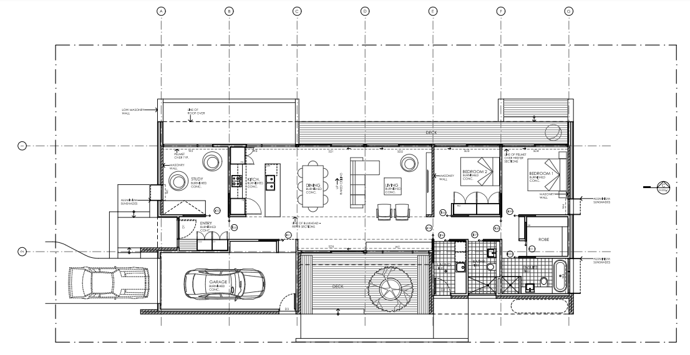

INSTALL A WATER TANK AND PIPE WORK
Tools Required:  - Add to this list | Fittings and Fixtures Required:  - Add to this list
PROCEDURE
Step:
- What needs to be prepared for this job
- Add to your procedural list here

LEGISLATION
- Reference any legislation that relates to this job or the environment the appliance / fitting is located in.
- Add to list here
- Add to list here
CALCULATIONS

Add an image of any calculations you did here

HEALTH AND SAFETY RISK ASSESSMENT
Complete the following form for this job as a hard copy and get your Tutor to sign it. Add a quality photo or photocopy of your completed form in the space below.

HEALTH AND SAFETY RISK ASSESSMENT FORM
ACTIVITY: Water Tank

IDENTIFY RISKS: Highlight / tick those that apply
Tick the potential risks(s) for this activity:
- Slips, trips and falls | - Heavy items that could fall | - Sharp objects or tools | - Electrical equipment (incl. power tools)
- Gas equipment | - Machinery (moving parts) | - Machinery (sparks) | - Hand tools
- Toxic fumes and dust | - Poisonous chemicals | - Flammable substances | - Excessive noise
- Ladders (heights) | - Temperature | - Fatigue | - Flames
List any other risks:
Add text here

RISK CONTROL METHOD:
Write what you will do to eliminate or minimise each risk:
RISK: | WHAT MIGHT HAPPEN: | HOW YOU WILL ELIMINATE: | HOW YOU WILL MINIMISE:
PERSONAL PROTECTIVE EQUIPMENT (PPE):
Tick the personal protective equipment (PPE) needed to complete this activity:
- Footwear | - Overalls | - Safety glasses | - Safety gloves
- Welding mask | - Earmuffs / earplugs | - Hard hat | - Hi-vis vest
List any other personal protective equipment (PPE) required:
Add text here

Add text here
Write or draw about what you plan to do to complete this activity.
PLANNING:

TUTOR SIGNATURE: |  | DATE:

Photographic Evidence of Water Tank installation and pipe work

Step 1 | Step 2
In a paragraph explain what is happening in this picture. | In a paragraph explain what is happening in this picture.
Step 3 | Step 4
In a paragraph explain what is happening in this picture. | In a paragraph explain what is happening in this picture.
Step 5 | Step 6
In a paragraph explain what is happening in this picture. | In a paragraph explain what is happening in this picture.

INSTALL A LOW-PRESSURE HOT WATER CYLINDER AND PIPE WORK
Tools Required:  - Add to this list | Fittings and Fixtures Required:  - Add to this list
PROCEDURE
Step:
- What needs to be prepared for this job
- Add to your procedural list here

LEGISLATION
- Reference any legislation that relates to this job or the environment the appliance / fitting is located in.
- Add to list here
- Add to list here
CALCULATIONS

Add an image of any calculations you did here

HEALTH AND SAFETY RISK ASSESSMENT
Complete the following form for this job as a hard copy and get your Tutor to sign it. Add a quality photo or photocopy of your completed form in the space below.

HEALTH AND SAFETY RISK ASSESSMENT FORM
ACTIVITY: Hot Water Cylinder

IDENTIFY RISKS: Highlight / tick those that apply
Tick the potential risks(s) for this activity:
- Slips, trips and falls | - Heavy items that could fall | - Sharp objects or tools | - Electrical equipment (incl. power tools)
- Gas equipment | - Machinery (moving parts) | - Machinery (sparks) | - Hand tools
- Toxic fumes and dust | - Poisonous chemicals | - Flammable substances | - Excessive noise
- Ladders (heights) | - Temperature | - Fatigue | - Flames
List any other risks:
Add text here

RISK CONTROL METHOD:
Write what you will do to eliminate or minimise each risk:
RISK: | WHAT MIGHT HAPPEN: | HOW YOU WILL ELIMINATE: | HOW YOU WILL MINIMISE:
PERSONAL PROTECTIVE EQUIPMENT (PPE):
Tick the personal protective equipment (PPE) needed to complete this activity:
- Footwear | - Overalls | - Safety glasses | - Safety gloves
- Welding mask | - Earmuffs / earplugs | - Hard hat | - Hi-vis vest
List any other personal protective equipment (PPE) required:
Add text here

Add text here
Write or draw about what you plan to do to complete this activity.
PLANNING:

TUTOR SIGNATURE: |  | DATE:

Photographic Evidence of Low-Pressure Hot Water Cylinder Installation and pipe work

Step 1 | Step 2
In a paragraph explain what is happening in this picture. | In a paragraph explain what is happening in this picture.
Step 3 | Step 4
In a paragraph explain what is happening in this picture. | In a paragraph explain what is happening in this picture.
Step 5 | Step 6
In a paragraph explain what is happening in this picture. | In a paragraph explain what is happening in this picture.

