PORTFOLIO 2: FOUL WATER PORTFOLIO

STUDENT SUBMISSION

Student Name: Add your name here Student ID: Add number here

Stream: Add Year and Semester

Submit this document by the due date to Moodle when you have completed it.

FOUL WATER PORTFOLIO

**Introduction**

This course covers the foundation knowledge and practical skills to assist with the installation of foul waster plumbing systems and perform basic plumbing maintenance, under supervision and further develop work-ready capabilities.

**Learning Outcomes:**

By the end of this course the student will be able to:

1. Describe biohazards in relation to plumbing and drain laying work
2. Identify and install basic foul water plumbing systems
3. Install basic plumbing fixtures
4. Maintain taps and valves
5. Apply work-readiness capabilities

**Learning Outcome 1:**

Describe biohazards in relation to plumbing and drain laying work.

This outcome is assessed by:

1. Describe 3 biohazards that you may encounter when you are working with sources of waste in plumbing and drain laying and provide an example of how you might deal with this.

Biohazard 1:

Biohazard 2:

Biohazard 3:

**Learning Outcome 2:**

Identify and install basic foul water plumbing systems.

This outcome is assessed by:

1. What is a foul water plumbing system?
2. Add a picture of the work you have done with foul water plumbing systems.

Add Labelled photograph of your work here

**Learning Outcome 3:**

Install basic plumbing fixtures

This outcome is assessed by:

1. Add a picture(s) of the basic plumbing fixtures that you have installed (taps, shower and handbasin)

Add Labelled photograph of your work here

Add Labelled photograph of your work here

Add Labelled photograph of your work here

**Code requirements:**

**Notching and drilling into structural material:**

Add text here

**Penetrations through walls and floors:**

Add text here

**Care of the customers property:**

List at least 4 precautions to take care of the customers property?

**Learning Outcome 4:**

Maintain taps and valves

This outcome is assessed by:

1. List four things that you could do to maintain your taps and valves and why you would do this?

House Drainage Plan

On the following house plan mark all the drainage needed for all the household sanitary fixtures, include:

* Minimum pipe sizes
* Vents
* Gullies/ Overflow relief

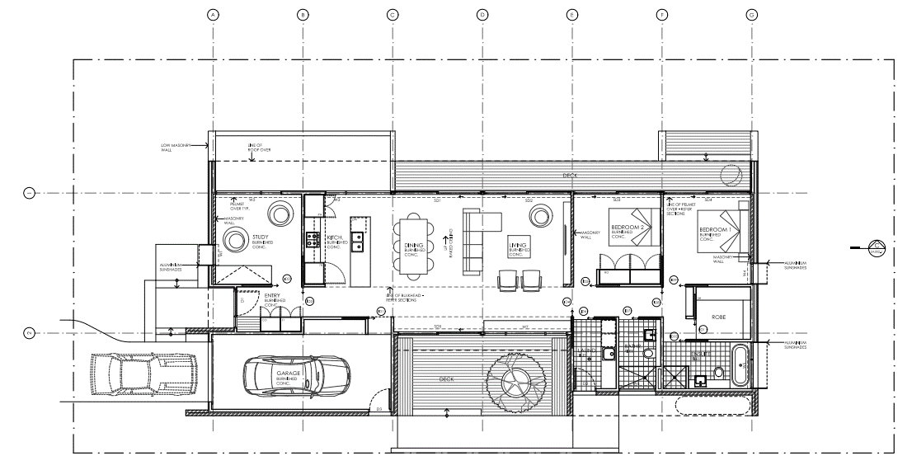

|  |  |
| --- | --- |
| Install basic foul water plumbing systems | |
| Tools Required:   * Add to this list | Fittings and Fixtures Required:   * Add to this list |
| PROCEDURE | |
| Step:   1. What needs to be prepared for this job 2. Add to your procedural list here | |
| LEGISLATION | |
| 1. Reference any legislation that relates to this job or the environment the appliance / fitting is located in. 2. Add to list here 3. Add to list here | |
|  | |
|  | |
|  | |
| CALCULATIONS | |
| Add an image of any calculations you did here | |

**HEALTH AND SAFETY RISK ASSESSMENT**

Complete the following form for this job as a hard copy and get your Tutor to sign it. Add a quality photo or photocopy of your completed form in the space below.

HEALTH AND SAFETY RISK ASSESSMENT FORM

**ACTIVITY: Roof and Wall pipe penetrations**

|  |  |  |  |
| --- | --- | --- | --- |
| **IDENTIFY RISKS: Highlight / tick those that apply** | | | |
| Tick the potential risks(s) for this activity: | | | |
| * Slips, trips and falls | * Heavy items that could fall | * Sharp objects or tools | * Electrical equipment (incl. power tools) |
| * Gas equipment | * Machinery (moving parts) | * Machinery (sparks) | * Hand tools |
| * Toxic fumes and dust | * Poisonous chemicals | * Flammable substances | * Excessive noise |
| * Ladders (heights) | * Temperature | * Fatigue | * Flames |
| List any other risks:  Add text here | | | |

|  |  |  |  |
| --- | --- | --- | --- |
| **RISK CONTROL METHOD:** | | | |
| Write what you will do to eliminate or minimise each risk: | | | |
| **RISK:** | **WHAT MIGHT HAPPEN:** | **HOW YOU WILL ELIMINATE:** | **HOW YOU WILL MINIMISE:** |
|  |  |  |  |
|  |  |  |  |
|  |  |  |  |
|  |  |  |  |

|  |  |  |  |
| --- | --- | --- | --- |
| **PERSONAL PROTECTIVE EQUIPMENT (PPE):** | | | |
| Tick the personal protective equipment (PPE) needed to complete this activity: | | | |
| * Footwear | * Overalls | * Safety glasses | * Safety gloves |
| * Welding mask | * Earmuffs / earplugs | * Hard hat | * Hi-vis vest |
| List any other personal protective equipment (PPE) required:  Add text here | | | |

Add text here

Write or draw about what you plan to do to complete this activity.

**PLANNING:**

|  |  |  |  |
| --- | --- | --- | --- |
| **TUTOR SIGNATURE:** |  | **DATE:** |  |

Photographic Evidence of Basic foul water plumbing systems

|  |  |
| --- | --- |
| Step 1 | Step 2 |
| In a paragraph explain what is happening in this picture. | In a paragraph explain what is happening in this picture. |
| Step 3 | Step 4 |
| In a paragraph explain what is happening in this picture. | In a paragraph explain what is happening in this picture. |
| Step 5 | Step 6 |
| In a paragraph explain what is happening in this picture. | In a paragraph explain what is happening in this picture. |

|  |  |
| --- | --- |
| INSTALL BASIC PLUMBING FIXTURES | |
| Tools Required:   * Add to this list | Fittings and Fixtures Required:   * Add to this list |
| PROCEDURE | |
| Step:   1. What needs to be prepared for this job 2. Add to your procedural list here | |
| LEGISLATION | |
| 1. Reference any legislation that relates to this job or the environment the appliance / fitting is located in. 2. Add to list here 3. Add to list here | |
|  | |
|  | |
|  | |
| CALCULATIONS | |
| Add an image of any calculations you did here | |

**HEALTH AND SAFETY RISK ASSESSMENT**

Complete the following form for this job as a hard copy and get your Tutor to sign it. Add a quality photo or photocopy of your completed form in the space below.

HEALTH AND SAFETY RISK ASSESSMENT FORM

**ACTIVITY: ROOF CLADDINGS AND FLASHINGS**

|  |  |  |  |
| --- | --- | --- | --- |
| **IDENTIFY RISKS: Highlight / tick those that apply** | | | |
| Tick the potential risks(s) for this activity: | | | |
| * Slips, trips and falls | * Heavy items that could fall | * Sharp objects or tools | * Electrical equipment (incl. power tools) |
| * Gas equipment | * Machinery (moving parts) | * Machinery (sparks) | * Hand tools |
| * Toxic fumes and dust | * Poisonous chemicals | * Flammable substances | * Excessive noise |
| * Ladders (heights) | * Temperature | * Fatigue | * Flames |
| List any other risks:  Add text here | | | |

|  |  |  |  |
| --- | --- | --- | --- |
| **RISK CONTROL METHOD:** | | | |
| Write what you will do to eliminate or minimise each risk: | | | |
| **RISK:** | **WHAT MIGHT HAPPEN:** | **HOW YOU WILL ELIMINATE:** | **HOW YOU WILL MINIMISE:** |
|  |  |  |  |
|  |  |  |  |
|  |  |  |  |
|  |  |  |  |

|  |  |  |  |
| --- | --- | --- | --- |
| **PERSONAL PROTECTIVE EQUIPMENT (PPE):** | | | |
| Tick the personal protective equipment (PPE) needed to complete this activity: | | | |
| * Footwear | * Overalls | * Safety glasses | * Safety gloves |
| * Welding mask | * Earmuffs / earplugs | * Hard hat | * Hi-vis vest |
| List any other personal protective equipment (PPE) required:  Add text here | | | |

Add text here

Write or draw about what you plan to do to complete this activity.

**PLANNING:**

|  |  |  |  |
| --- | --- | --- | --- |
| **TUTOR SIGNATURE:** |  | **DATE:** |  |

Photographic evidence of basic plumbing fixtures

|  |  |
| --- | --- |
| Step 1 | Step 2 |
| In a paragraph explain what is happening in this picture. | In a paragraph explain what is happening in this picture. |
| Step 3 | Step 4 |
| In a paragraph explain what is happening in this picture. | In a paragraph explain what is happening in this picture. |
| Step 5 | Step 6 |
| In a paragraph explain what is happening in this picture. | In a paragraph explain what is happening in this picture. |

**Learning Outcome 5:**

Create an instructional job card

An instructional Job card will include the following:

1. The installation steps in order from beginning to end
   * These might include acceptable solutions for the job
2. Tool list
3. An equipment (fittings / fixtures list)
4. A completed Health and Safety Risk Assessment form.
5. Any legislative requirements that need to be followed

May include:

1. a sketch or diagram describing the job
2. Any relevant calculations

|  |  |
| --- | --- |
| INSTALL A HAND BASIN | |
| Tools Required:   * Add to this list | Fittings and Fixtures Required:   * Add to this list |
| PROCEDURE | |
| Step:   1. What needs to be prepared for this job 2. Add to your procedural list here | |
| LEGISLATION | |
| 1. Reference any legislation that relates to this job or the environment the appliance / fitting is located in. 2. Add to list here 3. Add to list here | |
|  | |
|  | |
|  | |
| CALCULATIONS | |
| Shape  Description automatically generated with medium confidence  Add an image of any calculations you did here | |

**HEALTH AND SAFETY RISK ASSESSMENT**

Complete the following form for this job as a hard copy and get your Tutor to sign it. Add a quality photo or photocopy of your completed form in the space below.

HEALTH AND SAFETY RISK ASSESSMENT FORM

**ACTIVITY: Hand Basin**

|  |  |  |  |
| --- | --- | --- | --- |
| **IDENTIFY RISKS: Highlight / tick those that apply** | | | |
| Tick the potential risks(s) for this activity: | | | |
| * Slips, trips and falls | * Heavy items that could fall | * Sharp objects or tools | * Electrical equipment (incl. power tools) |
| * Gas equipment | * Machinery (moving parts) | * Machinery (sparks) | * Hand tools |
| * Toxic fumes and dust | * Poisonous chemicals | * Flammable substances | * Excessive noise |
| * Ladders (heights) | * Temperature | * Fatigue | * Flames |
| List any other risks:  Add text here | | | |

|  |  |  |  |
| --- | --- | --- | --- |
| **RISK CONTROL METHOD:** | | | |
| Write what you will do to eliminate or minimise each risk: | | | |
| **RISK:** | **WHAT MIGHT HAPPEN:** | **HOW YOU WILL ELIMINATE:** | **HOW YOU WILL MINIMISE:** |
|  |  |  |  |
|  |  |  |  |
|  |  |  |  |
|  |  |  |  |

|  |  |  |  |
| --- | --- | --- | --- |
| **PERSONAL PROTECTIVE EQUIPMENT (PPE):** | | | |
| Tick the personal protective equipment (PPE) needed to complete this activity: | | | |
| * Footwear | * Overalls | * Safety glasses | * Safety gloves |
| * Welding mask | * Earmuffs / earplugs | * Hard hat | * Hi-vis vest |
| List any other personal protective equipment (PPE) required:  Add text here | | | |

Add text here

Write or draw about what you plan to do to complete this activity.

**PLANNING:**

|  |  |  |  |
| --- | --- | --- | --- |
| **TUTOR SIGNATURE:** |  | **DATE:** |  |

Photographic Evidence of hand basin installation

|  |  |
| --- | --- |
| Shape  Description automatically generated with medium confidenceStep 1 | Shape  Description automatically generated with medium confidenceStep 2 |
| In a paragraph explain what is happening in this picture. | In a paragraph explain what is happening in this picture. |
|  |  |
| In a paragraph explain what is happening in this picture. | In a paragraph explain what is happening in this picture. |
|  |  |
| In a paragraph explain what is happening in this picture. | In a paragraph explain what is happening in this picture. |

Learning Outcome 6:

**Apply work-readiness capabilities**

Add a signed (Tutor) and verified (Manager) copy of the Work readiness Tutor Sign off sheet here.