self-assessment for Quizzes Online
Quiz Name
Tutor Name |  | Start date

I have:

☐ Named the quiz
☐ Put it in the correct topic
☐ Explained how to use it
☐ Explained how long it will be open
☐ Described what it covers or its purpose
☐ Checked spelling, grammar and correct question style – ie no question marks after a sentence
☐ Provided useful feedback for each question
☐ Provided overall feedback if appropriate
☐ Set the correct number of attempts (in Edit quiz settings)
☐ Checked the review options I want:

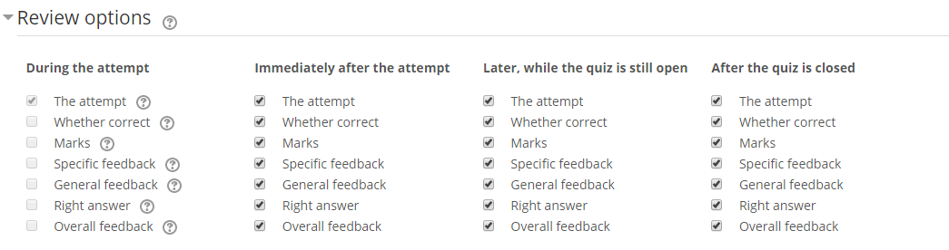
☐ Opened it/set a time for it to be open
The quiz:

☐ Covers the topics I want
☐ Has the questions on the right number of pages
☐ Is easy to navigate

I know how to:

☐ See who has attempted the quiz
☐ See each student’s marks
☐Delete attempts if the student wishes to retry
☐ Regrade
☐ Export the results
☐ Hide or close the quiz

