FS3133: Measurement: Exercise
You are to give advice to a young married couple on the type of flooring they want to install in their kitchen.
They have narrowed their decision down to two types of material:
- Tiles
- Wood
After talking to them a bit you learned that the lady likes to wear high heel shoes.
- Flat soled high heel shoes  - 150 mm long  - 70 mm wide | - Thin heeled high heel shoes  - Heel: 10 mm long  - Heel: 10 mm wide
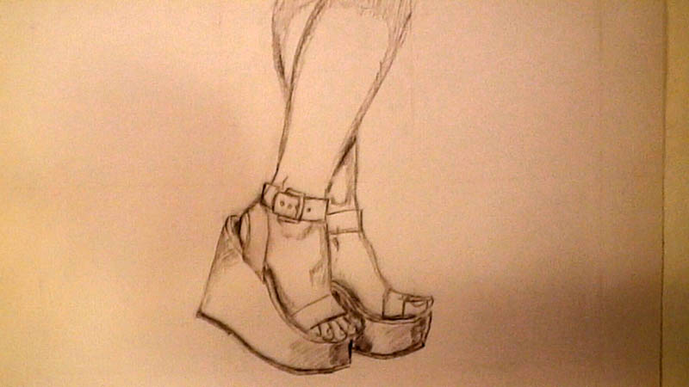 | 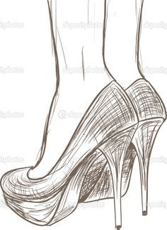

The lady has a mass of 60 kg.
Exercise:
- Calculate the pressure on the floor for each of the types of shoes when the lady walks in her kitchen.
- Based on the pressure of the shoe type, give advice on the type of floor.

Complete the exercise in class on page two. Keep your findings as preparation for, and to be handed in with your portfolio.
Pictures reference:
https://www.google.co.nz/search?q=high+heel+shoes+sketch&biw=1920&bih=934&source=lnms&tbm=isch&sa=X&ved=0ahUKEwjc4PWXirnSAhVJO7wKHeqgDKoQ_AUICCgD#imgrc=PaW2e39ThJBxHM:

FS3133: Pressure Exercise Date: 03 March 2017
Name: | Student No:
Calculations:
Recommendation:

