


Checklist: Waste minimisation, destination & transport

Have you looked for opportunities for waste minimisation?

Activity | Type of Waste | Resulting From
 | - Construction/Demolition Materials  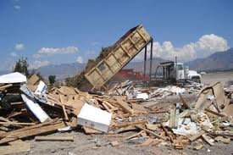 | - Construction or demolition works
 | - Water  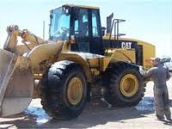 | - Cleaning, site works
 | - Chemicals  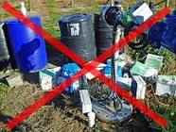 | - Gardening
 | - Organic Waste  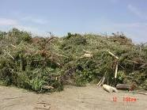 |  | - Gardening, open space maintenance
 | - Trade Waste  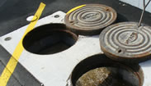 |  | - Restaurants, cafeteria
 | - Other
Hutt Valley Waste Management Plan 2004: http://www.huttcity.govt.nz/Documents/a-z/Waste%20management%20plan.pdf - Scroll through to Opportunities to Reduce Waste

New Zealand Waste Strategy: http://www.mfe.govt.nz/publications/waste/waste-strategy/index.html - Scroll through pages (next) and look for the section on Taking Responsibility

