TEST DOCUMENT - STUDENT SUBMISSION

Student Name: Add your name here Student ID: Add number here

Stream: Add Year and Stream

Submit this document by the due date to Moodle when you have completed it.

WATER SUPPLY

Learning Outcomes:

1. Investigate how water is supplied and treated
2. Investigate related legislative requirements
3. Recognise and name the components and fixtures related to a reticulation system
4. Produce an accurate installation diagram from a floor plan
5. Create an instructional job card
6. Prepare pipework for installation
7. Install under supervision a water reticulation system for hot and cold water
8. Install under supervision a low-pressure hot water system

**Learning Outcome 1:**

Investigate how water is supplied and treated

Add a diagram that you have created and labelled using key words that shows clearly the process of how water is supplied to a home, as clean potable water, then treated and recycled.

**Add diagram here**



[This Photo](https://commons.wikimedia.org/wiki/File:Picture_font_awesome.svg) by Unknown Author is licensed under [CC BY-SA](https://creativecommons.org/licenses/by-sa/3.0/)

**REPLACE THIS IMAGE**

In no more than two paragraphs describe your diagram using key words from the glossary.

**Add Description of the Water Supply and Treatment Process here.**

**REPLACE THIS IMAGE**



[This Photo](http://blazingfirebug.deviantart.com/art/College-Ruled-Paper-438389060) by Unknown Author is licensed under [CC BY-NC-ND](https://creativecommons.org/licenses/by-nc-nd/3.0/)

**Learning Outcome 2:**

Investigate related legislative requirements

G12: Requires the safe supply, storage, reticulation and delivery of hot and cold water.

In the table below provide a reference from the G12 document that relates to the following situations. Explain why this is important.

|  |  |  |
| --- | --- | --- |
| Situation | Building Code Reference | Why is this important? |
| Installing a sanitary hand basin |  |  |
| Storing potable water for home use |  |  |
| Supplying hot water to a tap |  |  |
| Another example |  |  |

**Learning Outcome 3:**

Recognise and name the components and fixtures related to a reticulation system

|  |  |  |
| --- | --- | --- |
| Image | Name of fixture | Purpose |
|  |  |  |
|  |  |  |
|  |  |  |
|  |  |  |
|  |  |  |
|  |  |  |
|  |  |  |
|  |  |  |
|  |  |  |
|  |  |  |
|  |  |  |

**Learning Outcome 4:**

Produce an accurate installation diagram from a floor plan

When installing pipework in a home it is useful to know where the pipes need to go. Referring to architectural plans and / or drawing a plan can help you think of issues ahead of time and plan your job more effectively.

On the following page add a picture of your completed floor plan for hot water and cold-water supply to the bathroom, toilet and kitchen.

Include:

1. Blue lines for cold
2. Red lines for hot water
3. Label where fixtures will be located
4. Label Mains water lines from council access
5. Label Foul water lines to council exit point

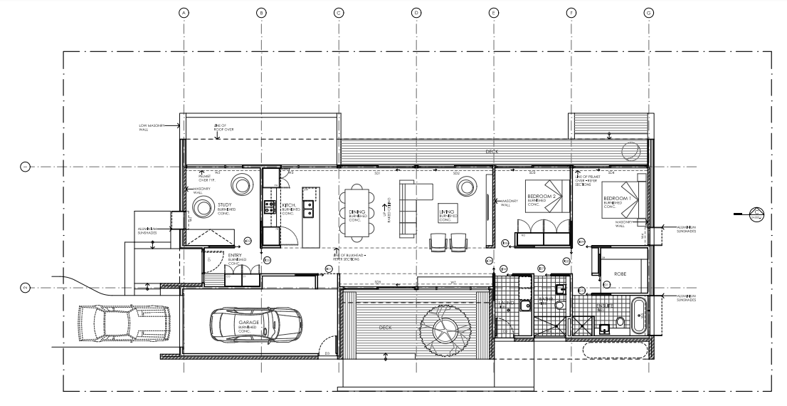

**Learning Outcome 5:**

Create an instructional job card

An instructional Job card will include the following:

1. The installation steps in order from beginning to end
   * These might include acceptable solutions for the job
2. Tool list
3. An equipment (fittings / fixtures list)
4. A completed Health and Safety Risk Assessment form.
5. Any legislative requirements that need to be followed

May include:

1. a sketch or diagram describing the job
2. Any relevant calculations

|  |  |
| --- | --- |
| INSTALL A HAND BASIN | |
| Tools Required:   * Add to this list | Fittings and Fixtures Required:   * Add to this list |
| PROCEDURE | |
| Step:   1. What needs to be prepared for this job 2. Add to your procedural list here | |
| LEGISLATION | |
| 1. Reference any legislation that relates to this job or the environment the appliance / fitting is located in. 2. Add to list here 3. Add to list here | |
|  | |
|  | |
|  | |
| CALCULATIONS | |
| Add an image of any calculations you did here | |

**HEALTH AND SAFETY RISK ASSESSMENT**

Complete the following form for this job as a hard copy and get your Tutor to sign it. Add a quality photo or photocopy of your completed form in the space below.

HEALTH AND SAFETY RISK ASSESSMENT FORM

**ACTIVITY: Hand Basin**

|  |  |  |  |
| --- | --- | --- | --- |
| **IDENTIFY RISKS: Highlight / tick those that apply** | | | |
| Tick the potential risks(s) for this activity: | | | |
| * Slips, trips and falls | * Heavy items that could fall | * Sharp objects or tools | * Electrical equipment (incl. power tools) |
| * Gas equipment | * Machinery (moving parts) | * Machinery (sparks) | * Hand tools |
| * Toxic fumes and dust | * Poisonous chemicals | * Flammable substances | * Excessive noise |
| * Ladders (heights) | * Temperature | * Fatigue | * Flames |
| List any other risks:  Add text here | | | |

|  |  |  |  |
| --- | --- | --- | --- |
| **RISK CONTROL METHOD:** | | | |
| Write what you will do to eliminate or minimise each risk: | | | |
| **RISK:** | **WHAT MIGHT HAPPEN:** | **HOW YOU WILL ELIMINATE:** | **HOW YOU WILL MINIMISE:** |
|  |  |  |  |
|  |  |  |  |
|  |  |  |  |
|  |  |  |  |

|  |  |  |  |
| --- | --- | --- | --- |
| **PERSONAL PROTECTIVE EQUIPMENT (PPE):** | | | |
| Tick the personal protective equipment (PPE) needed to complete this activity: | | | |
| * Footwear | * Overalls | * Safety glasses | * Safety gloves |
| * Welding mask | * Earmuffs / earplugs | * Hard hat | * Hi-vis vest |
| List any other personal protective equipment (PPE) required:  Add text here | | | |

Add text here

Write or draw about what you plan to do to complete this activity.

**PLANNING:**

|  |  |  |  |
| --- | --- | --- | --- |
| **TUTOR SIGNATURE:** |  | **DATE:** |  |

Photographic Evidence of hand basin installation

|  |  |
| --- | --- |
| Step 1 | Step 2 |
| In a paragraph explain what is happening in this picture. | In a paragraph explain what is happening in this picture. |
| Step 3 | Step 4 |
| In a paragraph explain what is happening in this picture. | In a paragraph explain what is happening in this picture. |
| Step 5 | Step 6 |
| In a paragraph explain what is happening in this picture. | In a paragraph explain what is happening in this picture. |

|  |  |
| --- | --- |
| INSTALL A WATER TANK AND PIPE WORK | |
| Tools Required:   * Add to this list | Fittings and Fixtures Required:   * Add to this list |
| PROCEDURE | |
| Step:   1. What needs to be prepared for this job 2. Add to your procedural list here | |
| LEGISLATION | |
| 1. Reference any legislation that relates to this job or the environment the appliance / fitting is located in. 2. Add to list here 3. Add to list here | |
|  | |
|  | |
|  | |
| CALCULATIONS | |
| Add an image of any calculations you did here | |

**HEALTH AND SAFETY RISK ASSESSMENT**

Complete the following form for this job as a hard copy and get your Tutor to sign it. Add a quality photo or photocopy of your completed form in the space below.

HEALTH AND SAFETY RISK ASSESSMENT FORM

**ACTIVITY: Water Tank**

|  |  |  |  |
| --- | --- | --- | --- |
| **IDENTIFY RISKS: Highlight / tick those that apply** | | | |
| Tick the potential risks(s) for this activity: | | | |
| * Slips, trips and falls | * Heavy items that could fall | * Sharp objects or tools | * Electrical equipment (incl. power tools) |
| * Gas equipment | * Machinery (moving parts) | * Machinery (sparks) | * Hand tools |
| * Toxic fumes and dust | * Poisonous chemicals | * Flammable substances | * Excessive noise |
| * Ladders (heights) | * Temperature | * Fatigue | * Flames |
| List any other risks:  Add text here | | | |

|  |  |  |  |
| --- | --- | --- | --- |
| **RISK CONTROL METHOD:** | | | |
| Write what you will do to eliminate or minimise each risk: | | | |
| **RISK:** | **WHAT MIGHT HAPPEN:** | **HOW YOU WILL ELIMINATE:** | **HOW YOU WILL MINIMISE:** |
|  |  |  |  |
|  |  |  |  |
|  |  |  |  |
|  |  |  |  |

|  |  |  |  |
| --- | --- | --- | --- |
| **PERSONAL PROTECTIVE EQUIPMENT (PPE):** | | | |
| Tick the personal protective equipment (PPE) needed to complete this activity: | | | |
| * Footwear | * Overalls | * Safety glasses | * Safety gloves |
| * Welding mask | * Earmuffs / earplugs | * Hard hat | * Hi-vis vest |
| List any other personal protective equipment (PPE) required:  Add text here | | | |

Add text here

Write or draw about what you plan to do to complete this activity.

**PLANNING:**

|  |  |  |  |
| --- | --- | --- | --- |
| **TUTOR SIGNATURE:** |  | **DATE:** |  |

Photographic Evidence of Water Tank installation and pipe work

|  |  |
| --- | --- |
| Step 1 | Step 2 |
| In a paragraph explain what is happening in this picture. | In a paragraph explain what is happening in this picture. |
| Step 3 | Step 4 |
| In a paragraph explain what is happening in this picture. | In a paragraph explain what is happening in this picture. |
| Step 5 | Step 6 |
| In a paragraph explain what is happening in this picture. | In a paragraph explain what is happening in this picture. |

|  |  |
| --- | --- |
| INSTALL A LOW-PRESSURE HOT WATER CYLINDER AND PIPE WORK | |
| Tools Required:   * Add to this list | Fittings and Fixtures Required:   * Add to this list |
| PROCEDURE | |
| Step:   1. What needs to be prepared for this job 2. Add to your procedural list here | |
| LEGISLATION | |
| 1. Reference any legislation that relates to this job or the environment the appliance / fitting is located in. 2. Add to list here 3. Add to list here | |
|  | |
|  | |
|  | |
| CALCULATIONS | |
| Add an image of any calculations you did here | |

**HEALTH AND SAFETY RISK ASSESSMENT**

Complete the following form for this job as a hard copy and get your Tutor to sign it. Add a quality photo or photocopy of your completed form in the space below.

HEALTH AND SAFETY RISK ASSESSMENT FORM

**ACTIVITY: Hot Water Cylinder**

|  |  |  |  |
| --- | --- | --- | --- |
| **IDENTIFY RISKS: Highlight / tick those that apply** | | | |
| Tick the potential risks(s) for this activity: | | | |
| * Slips, trips and falls | * Heavy items that could fall | * Sharp objects or tools | * Electrical equipment (incl. power tools) |
| * Gas equipment | * Machinery (moving parts) | * Machinery (sparks) | * Hand tools |
| * Toxic fumes and dust | * Poisonous chemicals | * Flammable substances | * Excessive noise |
| * Ladders (heights) | * Temperature | * Fatigue | * Flames |
| List any other risks:  Add text here | | | |

|  |  |  |  |
| --- | --- | --- | --- |
| **RISK CONTROL METHOD:** | | | |
| Write what you will do to eliminate or minimise each risk: | | | |
| **RISK:** | **WHAT MIGHT HAPPEN:** | **HOW YOU WILL ELIMINATE:** | **HOW YOU WILL MINIMISE:** |
|  |  |  |  |
|  |  |  |  |
|  |  |  |  |
|  |  |  |  |

|  |  |  |  |
| --- | --- | --- | --- |
| **PERSONAL PROTECTIVE EQUIPMENT (PPE):** | | | |
| Tick the personal protective equipment (PPE) needed to complete this activity: | | | |
| * Footwear | * Overalls | * Safety glasses | * Safety gloves |
| * Welding mask | * Earmuffs / earplugs | * Hard hat | * Hi-vis vest |
| List any other personal protective equipment (PPE) required:  Add text here | | | |

Add text here

Write or draw about what you plan to do to complete this activity.

**PLANNING:**

|  |  |  |  |
| --- | --- | --- | --- |
| **TUTOR SIGNATURE:** |  | **DATE:** |  |

Photographic Evidence of Low-Pressure Hot Water Cylinder Installation and pipe work

|  |  |
| --- | --- |
| Step 1 | Step 2 |
| In a paragraph explain what is happening in this picture. | In a paragraph explain what is happening in this picture. |
| Step 3 | Step 4 |
| In a paragraph explain what is happening in this picture. | In a paragraph explain what is happening in this picture. |
| Step 5 | Step 6 |
| In a paragraph explain what is happening in this picture. | In a paragraph explain what is happening in this picture. |